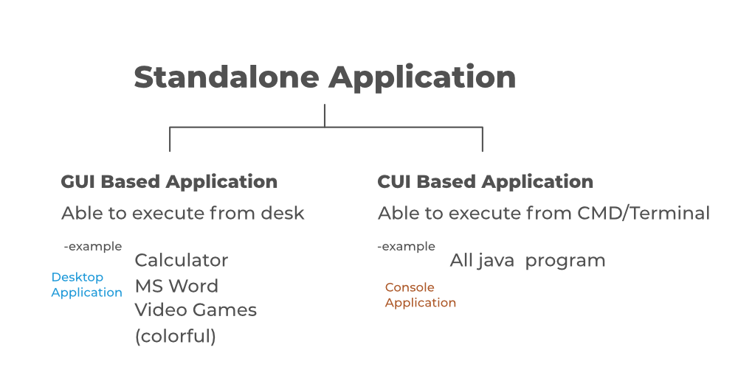

What is Spring Framework ? [ Java ]
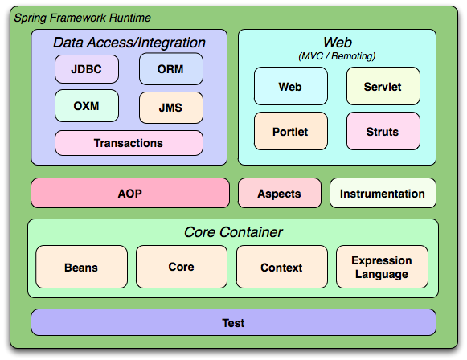
Spring Framework is a comprehensive and versatile platform for enterprise Java development. It is known for its Inversion of Control (IoC) and Dependency Injection (DI) capabilities that simplify creating modular and testable applications. Key features include Spring MVC for web development, Spring Boot for rapid application setup, and Spring Security for robust authentication and authorization. With a rich ecosystem covering Spring Data for database interactions and Spring Cloud for building microservices, Spring supports scalable and resilient enterprise solutions, making it an essential framework for developers of all experience levels.
Lets Cover essential topics like dependency injection, Spring MVC, and Spring Boot , as well as advanced areas such as Spring Data, Spring AOP, and Spring Security. Whether you’re building web applications with Spring MVC or using Spring Boot for rapid development, this guide offers practical examples and real-world projects for beginners and experienced professionals.

What is Spring Framework?
Spring is a lightweight and popular open-source Java-based framework developed by Rod Johnson in 2003. It is used to develop enterprise-level applications. It provides support to many other frameworks such as Hibernate, Tapestry, EJB, JSF, Struts, etc. so it is also called a framework of frameworks. It’s an application framework and IOC (Inversion of Control) container for the Java platform. The spring contains several modules like IOC, AOP, DAO, Context, WEB MVC, etc.
Why to use Spring?
Spring framework is a Java platform that is open source. Rod Johnson created it, and it was first released under the Apache 2.0 license in June 2003. When it comes to size and transparency, Spring is a featherweight. Spring framework’s basic version is about 2MB in size. The Spring Framework’s core capabilities can be used to create any Java program, however there are modifications for constructing web applications on top of the Java EE platform. By offering a POJO-based programming model, the Spring framework aims to make J2EE development easier to use and to promote good programming habits.
Applications of Spring
- POJO Based: Spring allows developers to use POJOs to create enterprise-class apps. The advantage of using simply POJOs is that you don’t require an EJB container product like an application server; instead, you may use a powerful servlet container like Tomcat or a commercial product.
- Modular : Spring is set up in a modular approach. Even if there are a lot of packages and classes, you only need to worry about the ones you need and ignore the rest.
- Integration with Existing Frameworks: Spring does not reinvent the wheel; rather, it makes extensive use of existing technologies such as numerous ORM frameworks, logging frameworks, JEE, Quartz, and JDK timers, and other view technologies.
- Testability: Because environment-dependent code is put into this framework, testing a Spring-written application is trivial. Furthermore, using JavaBeanstyle POJOs makes it easier to employ dependency injection for injecting test data.
- Web MVC: Spring’s web framework is a well-designed web MVC framework that is an excellent alternative to web frameworks like Struts and other over-engineered or less popular web frameworks.
- Central Exception Handling: Spring provides a handy API for converting technology-specific exceptions (such as those raised by JDBC, Hibernate, or JDO) into consistent, unchecked exceptions.
- Lightweight: IoC containers are typically lightweight, especially when compared to EJB containers, for example. This is useful for creating and distributing programmers on systems with limited memory and CPU resources.
- Core Spring
- Spring Annotations
- Spring Boot
- Spring MVC
- Spring with REST API
- Spring Data JPA
- Spring JDBC
- Spring ORM or Spring Hibernate
- Spring AOP
- Spring Security

Spring Framework Architecture
The Spring framework is a widely-used open-source Java framework that provides a comprehensive programming and configuration model for building enterprise applications. Its architecture is designed around two core principles: Dependency Injection (DI) and Aspect-Oriented Programming (AOP).
The Spring framework consists of several modules, which can be categorized into 4 main areas:
- Core Container,
- Data Access/Integration,
- Web, and
- Miscellaneous.
The Core Container provides the fundamental functionality of the Spring framework, including the IoC container and ApplicationContext. The Data Access/Integration area provides support for integrating with databases and other data sources. The Web area provides support for building web applications, including the Spring MVC and Spring WebFlux modules. The Miscellaneous area includes other modules that provide additional functionality, such as the Spring Security module for authentication and authorization features.
- Dependency Injection (DI) is a design pattern that helps to reduce the coupling between the components of an application. By using DI, the Spring framework enables loose coupling between components, making the application more modular and easier to maintain. The Spring framework provides an Inversion of Control (IoC) container, which is responsible for creating and managing instances of JavaBeans, and the ApplicationContext, which provides a unified view of the entire application configuration.
- Aspect-Oriented Programming (AOP) allows developers to modularize cross-cutting concerns, such as logging, security, and transaction management, and apply them to multiple components of an application. This results in a more modular and reusable codebase. The Spring framework provides an AOP framework, which is responsible for managing cross-cutting concerns in the application, such as logging, security, and transaction management.
- Overall, the Spring framework architecture is based on the principles of modularity, separation of concerns, and flexibility, providing developers with a powerful set of tools to build robust, scalable, and maintainable enterprise applications. The framework’s modular architecture allows developers to select only the necessary modules for their specific needs, reducing unnecessary overhead and complexity in the application. Additionally, the Spring framework’s flexible configuration model allows developers to configure the application using various approaches, such as XML-based configuration, Java-based configuration, and annotation-based configuration.
Spring Modules

Spring Modules
The Spring framework is modular and consists of several modules that provide different functionalities to help build enterprise applications. The modules can be broadly categorized into four main areas: Core Container, Data Access/Integration, Web, and Miscellaneous. Let’s take a closer look at each area and its corresponding modules:
Core Container
- The Core Container provides the fundamental functionality of the Spring framework, including the Inversion of Control (IoC) container and the ApplicationContext. It includes the following modules:
- Spring Core:
This module provides the fundamental functionality of the Spring framework, including IoC and DI. The IoC container is the heart of the Spring Framework, responsible for creating and managing instances of JavaBeans. It uses dependency injection to wire the beans together.
- Spring Beans:
This module provides the BeanFactory, which is the basic building block of the IoC container, and the BeanWrapper, which is responsible for managing the lifecycle of a bean. The Bean Factory is the core interface for accessing the IoC container. It provides methods for retrieving beans.
- Spring Context:
This module provides the ApplicationContext, which is an advanced version of the BeanFactory and provides additional features, such as internationalization and resource loading, and the ability to publish and consume events.
- Spring Expression Language (SpEL):
This module provides a powerful expression language for querying and manipulating objects during runtime. SpEL supports a wide range of features, including property access, method invocation, conditionals, loops, and type conversion. It also provides support for accessing variables and functions defined in the application context, as well as support for defining custom functions and variables.
Data Access/Integration
- The Data Access/Integration area provides support for integrating with databases and other data sources. It includes the following modules:
  - Spring JDBC: This module provides a simple JDBC abstraction layer that reduces the amount of boilerplate code required to work with JDBC. Spring JDBC provides support for transaction management, allowing developers to manage database transactions declaratively using Spring’s transaction management.
  - Spring ORM: This module provides integration with Object-Relational Mapping (ORM) frameworks, such as Hibernate and JPA. Spring ORM provides a higher-level abstraction layer on top of ORM frameworks, allowing developers to write less boilerplate code and more easily integrate ORM technologies with other Spring features, such as transaction management and caching.
  - Spring Data: This module provides a consistent and easy-to-use programming model for working with data access technologies, including databases, NoSQL, and cloud-based data services. Spring Data provides a wide range of features, including automatic CRUD (Create, Read, Update, Delete) operations, query generation from method names, support for pagination and sorting, integration with Spring’s transaction management, and more. Additionally, Spring Data provides support for common data access patterns, such as repositories and data access objects (DAOs).
  - Spring Transaction: This module provides support for declarative transaction management in Spring applications. Spring Transaction provides support for various transaction propagation and isolation levels, allowing developers to manage transactions at different levels of granularity. Additionally, Spring Transaction provides support for different transaction management strategies, such as using a JTA transaction manager or a simple JDBC transaction manager.
Web
- The Web area provides support for building web applications. It includes the following modules:
  - Spring MVC: This module provides a Model-View-Controller (MVC) framework for building web applications. Spring MVC provides a range of features, including support for handling HTTP requests and responses, form handling, data binding, validation, and more. It also provides support for different view technologies, such as JSP (JavaServer Pages), Thymeleaf, and Velocity, allowing developers to choose the view technology that best suits their needs.
  - Spring WebFlux: This module provides a reactive programming model for building web applications that require high concurrency and scalability. Spring WebFlux provides support for building reactive web applications using a range of technologies, such as Netty, Undertow, and Servlet 3.1+ containers. It also provides a range of features, including support for reactive data access, reactive stream processing, and reactive HTTP clients.
  - Spring Web Services: This module provides support for building SOAP-based and RESTful web services. Spring Web Services provides support for generating WSDL (Web Services Description Language) from Java classes, and for generating Java classes from WSDL. This allows developers to define the contract (i.e., the interface) of their web service using WSDL, and to generate the Java classes that implement the web service from the WSDL.
Miscellaneous
- The Miscellaneous area includes other modules that provide additional functionality, such as:
  - Spring Security: This module provides authentication and authorization features for Spring applications. Spring Security provides a range of authorization mechanisms, such as role-based access control and expression-based access control. It also provides support for securing different parts of the application using different security configurations, allowing developers to apply fine-grained security policies.
  - Spring Integration: This module provides support for building message-driven and event-driven architectures. Spring Integration provides a range of integration patterns, such as messaging, routing, and transformation. It provides support for a range of messaging systems, such as JMS, AMQP, and Apache Kafka. It also provides support for integrating with different protocols, such as FTP, HTTP, and TCP.
  - Spring Batch: This module provides support for batch processing and integration with enterprise systems. Spring Batch provides a range of tools and utilities for building and managing batch processing applications, such as support for testing and debugging batch jobs, logging and monitoring, and integration with other Spring modules, such as Spring Data and Spring Integration.
  - Spring Cloud: This module provides support for building cloud-native applications using Spring technologies. Spring Cloud provides a range of features for building cloud-native applications, such as service discovery, configuration management, and load balancing. It provides support for integrating with different cloud platforms, such as AWS and GCP, and for using different cloud-native technologies, such as containers and serverless computing.
- Overall, the Spring framework modules provide developers with a powerful set of tools to build robust, scalable, and maintainable enterprise applications. The modular architecture of the Spring framework allows developers to select only the necessary modules for their specific needs, reducing unnecessary overhead and complexity in the application.
Conclusion
In conclusion, the Spring framework is a powerful and popular open-source Java framework that provides a comprehensive programming and configuration model for building enterprise applications. Its architecture is designed around the principles of modularity, separation of concerns, and flexibility, providing developers with a powerful set of tools to build robust, scalable, and maintainable enterprise applications.

